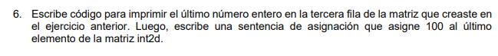
public static void main(String[] args) {
int[][] int2d = new int[5][10];
System.out.println(int2d[2][9]);
int2d[4][9] = 100;
}

